How to Make Your Pendrive Bootable
CAUTION: This process removes all data from USB drive (it formats drive). So, take backup of your pendrive before doing this process.

For installing Cent Os from Pen drive you need to first make your pendrive bootable. There are many ways of it. Here we use “unetbootin-windows-584” software for making pen drive bootable. Below Screen shows main screen of that software.

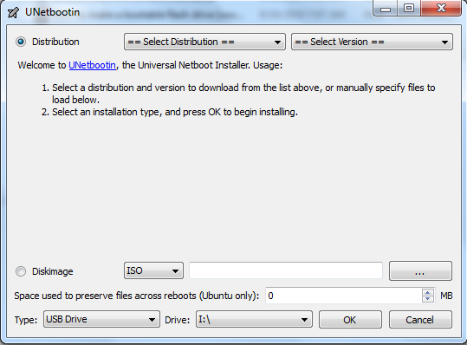

In this screen you need to select Cent Os as Distribution and version as 6_Live. Now as we are going to provide .iso file of Cent Os You need to choose Diskimage -> ISO and then you need to specify location of .iso file. In Type select USB Drive and specify drive letter appropriately as shown in below screen.

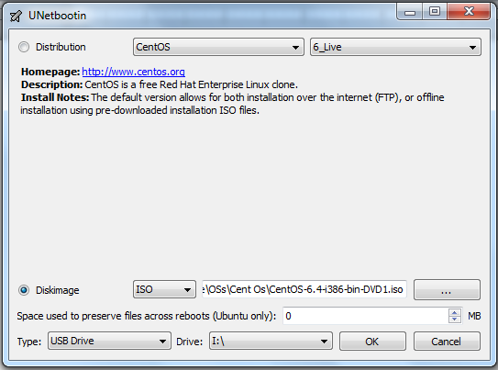
Once this all things are done we are ready to make our pendrive bootable. So Press OK which will lead you to following screen. Now wait till all 4 step are completed.

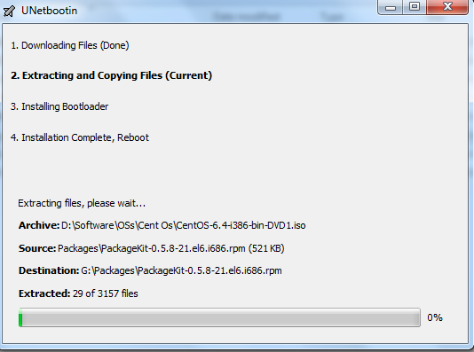

Once all steps are completed it will show you following screen. Then if you want to install now then select reboot or if you plan to install later then select Exit. So, by using this steps you can make your pendrive bootable.

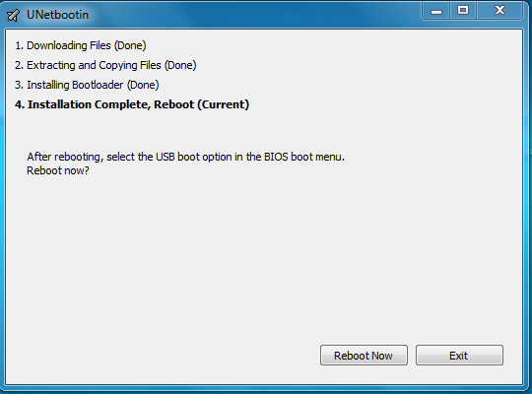

Live Media

If You don’t want to allocate special space for Linux or you don’t want to partition your hard disk and still wants to use Linux !!! Then live media is solution for you…… ☺ ☺ ☺
So for doing this you need to follow same process of making your pendrive bootable if you not having CD/DVD of distributor which support live image (Here, this tutorial will guide you by taking Fedora into consideration. If you try with different flavor of Linux then process may vary depend on provider).
Once your pendrive is bootable then reboot your machine. At startup press F12 (Note: some machine have F8 instead of F12). Select Install from USB Drive option and process with “Use Live CD/DVD” option. So after that if you follow all steps perfectly then you can access Your Linux without actually installing it on your machine. And once your work is done restart your machine to keep using your actual OS.

Tutorial Prepared BY:

- Prof. Hariom Pandya
- Prof. Jigar Pandya

